APEX_LUNA ROVER

|  |  |
| --- | --- |
| **A PROJECT REPORT** | |
| ***Submitted by***  **KISHORE T** | **(111519107010)** |
| **NITIN P** | **(111519107017)** |
| **UDHAYA KUMAR P** | **(111519107026)** |

# VARUN VISVESH S (111519107027)

***in partial fulfillment for the award of the degree***

***of***

# BACHELOR OF ENGINEERING

***in***

## ELECTRONICS AND INSTRUMENTATION ENGINEERING

**R.M.D ENGINEERING COLLEGE, KAVARAIPETTAI (An Autonomous Institution)**

# ANNA UNIVERSITY: CHENNAI 600 025

**MAR 2023**

|  |  |
| --- | --- |
| **ANNA UNIVERSITY – CHENNAI-600 025**  **BONAFIDE CERTIFICATE**  Certified that this project report **“APEX-LUNA ROVER”** is the bonafide work of KISHORE **T (111519107010), NI TI N P (111519107017), UDH AYA K UM AR P**  **(111519107026), VARUN VISVESH S (111519107027),** who carried out the project work under my supervision. | |
| **SIGNATURE** | **SIGNATURE** |
| Dr. A. Chilambuchelvan M.E, Ph.D., | Dr. G. Nalinashini M.E, Ph.D., |
| **HEAD OF THE DEPARTMENT** | **SUPERVISOR** |
| Professor | Professor |
| Department of Electronics and Instrumentation | Department of Electronics and Instrumentation |
| Engineering, | Engineering, |
| R.M.D. Engineering College, R.S.M. Nagar, | R.M.D. Engineering College, R.S.M. Nagar, |
| Kavaraipettai - 601206. | Kavaraipettai - 601206. |

**CERTIFICATE OF EVALUATION**

**College Name** R.M.D ENGINEERING COLLEGE

**Department** Electronics and Instrumentation Engineering

**Semester** 08

|  |  |  |
| --- | --- | --- |
| **Title of Project** | **Name of the Students with Register Numbers** | **Name of the Supervisor with Designation** |
| Industrial waste segregation and safety enhancement system | Kishore T (111515107010)  NitinP (111515107017)  Udhaya Kumar P(111515107026) Varun Visvesh S (111519107027) | Dr. G. Nalinashini M.E,Ph.D., Professor,  Department of Electronicsand Instrumentation Engineering |

The report of the project work submitted by the above students in partial fulfillment for the award of **Bachelor of Engineering Degree in ELECTRONICS AND INSTRUMENTATION ENGINEERING** of Anna University was evaluated and confirmed to be the report of the work done by the above students and then evaluated.

**Submitted the project during the Viva-Voce held on**

## INTERNAL EXAMINER EXTERNAL EXAMINER

**ACKNOWLEDGEMENT**

The success and final outcome of this project required a lot of guidance, Support and kind co-operation from many, for successful completion. We wish to express our sincere thanks to all those who were involved in the completion of this project.

It is our immense pleasure to express our deep sense of gratitude to our respected chairman **Thiru R. S. Munirathinam**, our vice chairman **Thiru**

**R. M. Kishore**, and our director **Thiru R. Jothi Naidu** for the facilities and support given by them in the college.

We are extremely thankful to our principal **Dr. N. Anbuchezhian, M.S, M.B.A, M.E, Ph.D.**, for given us an opportunity to serve the purpose of education.

We are indebted to **Dr. A. Chilambuchelvan, M.E, Ph.D.**, Professor and Head of the Department of Electronics and Instrumentation Engineering, as well as our project coordinator for providing the necessary guidance and constant encouragement for successful completion of this project on time.

We extend our sincere thanks and gratitude to our project guide Dr. G. Nalinashini M.E, Ph.D., Assistant Professor in the Department of Electronics and Instrumentation Engineering, who guided us all along till the completion of our project work.

Last but not the least, I wish to thank all the teaching and non-teaching staff of EIE department for their help in the completion of the project.

## ABSTRACT

To Detect obstacles and Analysis the land surface of the southern part of the lunar eclipse with the help of Rover. Apex-luna rover will travel to the Mare Nubium Nobile rim 2, 70-degree longitude towards southwest of the lunar, which is nearest to the tranquility base apollo lander, so it is simply way to land the Mission. Our rover will travel through the southwest part of the moon. Which will help to map the moon with the help of Sensor. Apex Luna rover is a specialized rover which can analysis the water chemical form and structures of the molecule with the help of digital microscope. It will also take a sample from the moon for further analysis of the moon surface. It will detect the object and capture the photo and move away from the object and with these images we can create a map.

|  |  |  |
| --- | --- | --- |
|  | **TABLE OF CONTENTS** |  |
| **CHAPTER NO.** | **TITLE** | **PAGE NO.** |
|  | **ABSTRACT** | **5** |
|  | **LIST OF FIGURES** | **10** |
|  | **LIST OF ABBREVIATIONS** | **11** |
| **1.** | **INTRODUCTION** | **12** |
|  | 1.1 MARE NUBIUM | 12 |
|  | 1.2 TRANQUILITY BASE | 13 |
|  | 1.2.1 Apex-Luna theroy? | 14 |
|  | 1.3 DOMAINS | 15 |
|  | 1.3.1 Embedded System | 15 |
|  | 1.3.1.1 Characteristics | 17 |
|  | 1.3.1.2 Processors in ES | 18 |
|  | 1.4 OBJECTIVE OF THE PROJECT | 18 |
| **2.** | **LITERATURE SURVEY** | **19** |
|  | 2.1 INTRODUCTION TO APEX-LUNA | 19 |
|  | 2.2 SUMMARY | 23 |
| **3.** | **SYSTEM ANALYSIS** | **24** |
|  | 3.1 EXISTING SYSTEM | 24 |
|  | 3.1.1 Disadvantages | 24 |
|  | 3.2 PROPOSED SYSTEM | 24 |
|  | 3.2.1 Advantages | 25 |
|  | 3.3 SUMMARY | 26 |

1. SYSTEM DESIGN 27
   1. BLOCK DIAGRAM 27
2. HARDWARE DESCRIPTION 28
   1. MICROCONTROLLER 28
      1. General Description 28
      2. Product Description 28
      3. Hardware Needed 28
      4. Features 29
      5. Applications 30
   2. POWER SUPPLY 30
      1. 32 volt Battery 30
      2. Solar pannel 31
      3. Thermoelectric generator 33
   3. Motor circuit connection 34
      1. Features 34
   4. Digital Microscope 35
   5. Ultrasonic sensor 37
      1. Pin Configuration 38
      2. ultrasonic sensor in a sensor shield 38
   6. 12v DC MOTOR 40
      1. Features 41
   7. OLED DISPLAY 41
      1. Features 41
   8. AMPLIFIER 42
      1. Features 43
      2. Applications 43
   9. DC-DC COVERTER 44
      1. Features 44
      2. Applications 44
   10. SENSOR SHEILD V5 45
       1. Features 45
   11. LED STRIP 47
       1. Features 47
       2. Applications 48
   12. SUMMARY 48
3. SOFTWARE DESCRIPTION 49
   1. EMBEDDED C 49
      1. Description 51
      2. Multiple Address Spaces 51
      3. Named Registers 53
      4. I/O Hardware Addressing 53
      5. Embedded C Portability 55
   2. ARDUINO SOFTWARE(IDE) 57
      1. Arduino Bootloader Issue 58
      2. Software Needed 59
      3. Bootloader Download Instructions 59
   3. CODE 62
4. WEBSITE DETAILS 64
   1. HTML 67

7.2 CSS 3 68

* 1. JAVA SCRIPT 69
  2. OPENCV 70
     1. Water molecule detection 70
  3. Website Images 70

1. CONCLUSION 72
2. REFERENCES 73

## LIST OF FIGURES

**FIGURE NO. TITLE PAGE NO.**

* 1. Mare Nubium 13
  2. Mare Traquility Base 14
  3. Embedded System 17
  4. Block Diagram 27
  5. Arduino Uno 30
  6. 32 volt Battery 31
  7. Solar pannel 32
  8. Thermoelectric generator 33
  9. L298N Motor Driver Module 34
  10. L298N Pin Configuration 35
  11. Ultrasonic Laser Sensor 36
  12. Digital Microscope 37
  13. Sensor Shield v5 38
  14. Amplifier 39
  15. 12 volt Dc Motor 41
  16. OLED Display 42
  17. Soil Moisture Sensor 43
  18. DC Motor 44
  19. IOT Module 47
  20. 12V LED Strip 48

## LIST OF ABBREVIATIONS

**KEYWORD ABBREVIATION**

MAR Maintenance and Refurbishment in Space OLED Organic light-emitting diode

μP Microprocessor

μC Microcontroller

Memory

CPU Central Processing Unit

RISC Reduced Instruction Set Computer

DSP Digital Signal Processor

LED Light Emitting Diode

DC Direct Current

USB Universal Serial Bus

IDE Integrated Development Environment

SRAM Static Random Access Memory

EPROM Erasable Programmable Read Only

LOLA Lunar Orbiter Laser Altimeter

RPM Revolutions Per Minute

UART Universal asynchronous receiver transmitter

# CHAPTER 1 : INTRODUCTION

## INDUSTRIAL AUTOMATION

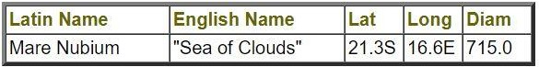

Mare Nubium

|  |  |
| --- | --- |
| **Feature Name** | Mare Nubium |

|  |  |
| --- | --- |
| **Clean Name** | Mare Nubium |
| **Feature ID** | 3684 |
| **Target** | Moon |
| **Feature Type** | Mare, maria |
| **Coordinate System** | Planetographic, +East, -180 - 180 |
| **Control Network** | LOLA 2011 |
| **Northernmost Latitude** | -11.85 ° |
| **Southernmost Latitude** | -30.48 ° |
| **Easternmost Longitude** | -5.45 ° |
| **Westernmost Longitude** | -29.27 ° |
| **Diameter** | 714.50 KM |
| **Center Latitude** | -20.59 ° |
| **Center Longitude** | -17.29 ° |
| **Continent** | Europe |
| **Ethnic/Cultural Group or Country** | Latin |
| **Quad** | LAC-94 [[pdf](https://asc-planetarynames-data.s3.us-west-2.amazonaws.com/Lunar/lac_94_wac.pdf)] |
| **Reference** | [66] - Named Lunar Formations, by Mary A. Blagg and K. Müller: Percy Lund, Humphries and Co. Ltd., London, 1935. |
| **Approval Status** | Adopted by IAU |
| **Approval Date** | 1935 |
| **Origin** | "Sea of Clouds." |
| **Last Updated** | Oct 18, 2010 12:00 PM |

The pre-Nectarian Mare Nubium covers geographically nearly two-thirds of the area under study, centred at 21.3 S 16.6 W. Its official name since 1935, Mare Nubium, or “Sea of Clouds”, derives from early telescopic observations. The mare’s numerous ghost features, and various higher-albedo crater ejecta criss- crossing the basin, conjured up the idea of lunar clouds. Mare Nubium has a

diameter of 750 km, and it is one of the most ancient circular basins on the Moon (Stuart-Alexander and Howard, 1970). Nevertheless, there is clear evidence that the basin did not form by a single large impact. Its present morphology appears to be a consequence of a number of major collisions. Morphological evidence of at least four major basin rings is still clearly identifiable (i.e. De Hon, 1977).

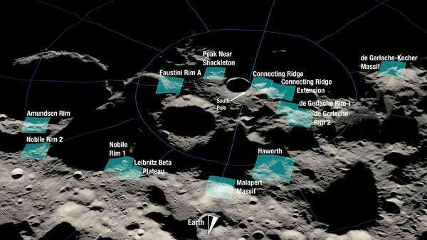

MAP OF MARE NUBIUM

## TRANQUILITY BASE:

Tranquility Base ([Latin](https://en.wikipedia.org/wiki/Latin_language): *Statio Tranquillitatis*) is the site on the [Moon](https://en.wikipedia.org/wiki/Moon) where, in July 1969, humans landed and walked on a [celestial body](https://en.wikipedia.org/wiki/Celestial_body) other than [Earth](https://en.wikipedia.org/wiki/Earth) for the first time. On July 20, 1969, [Apollo 11](https://en.wikipedia.org/wiki/Apollo_11) crewmembers [Neil Armstrong](https://en.wikipedia.org/wiki/Neil_Armstrong) and [Buzz](https://en.wikipedia.org/wiki/Buzz_Aldrin) [Aldrin](https://en.wikipedia.org/wiki/Buzz_Aldrin) landed their [Apollo Lunar Module](https://en.wikipedia.org/wiki/Apollo_Lunar_Module) [*Eagle*](https://en.wikipedia.org/wiki/Lunar_Module_Eagle) at approximately 20:17:40 [UTC](https://en.wikipedia.org/wiki/Universal_Coordinated_Time). Armstrong exited the spacecraft six hours and 39 minutes after touchdown, followed 19 minutes later by Aldrin. The [astronauts](https://en.wikipedia.org/wiki/Astronauts) spent two hours and 31 minutes examining and photographing the lunar surface, setting up several scientific experiment packages, and collecting 47.5 pounds (21.5 kg) of [dirt and](https://en.wikipedia.org/wiki/Moon_rocks)

[rock samples](https://en.wikipedia.org/wiki/Moon_rocks) for return to Earth. They lifted off the surface on July 21 at 17:54 UTC.

Tranquility Base was named by Aldrin and Armstrong, and first announced by Armstrong when the [Lunar Module *Eagle*](https://en.wikipedia.org/wiki/Lunar_Module_Eagle)landed. It is located in the south- western corner of the dark lunar plain [Mare Tranquillitatis](https://en.wikipedia.org/wiki/Mare_Tranquillitatis) ("Sea of Tranquility").The U.S. states of [California](https://en.wikipedia.org/wiki/California) and [New Mexico](https://en.wikipedia.org/wiki/New_Mexico) have registered Tranquility Base as a heritage site associated with them, but [Texas](https://en.wikipedia.org/wiki/Texas), the U.S. [National Park Service](https://en.wikipedia.org/wiki/National_Park_Service), and [UNESCO](https://en.wikipedia.org/wiki/United_Nations_Educational%2C_Scientific_and_Cultural_Organization) have declined to do so, due to the technicality that it is not located within their borders.

For more than two years, [NASA](https://en.wikipedia.org/wiki/NASA) planners considered a collection of 30 potential sites for the first crewed landing. Based on high-resolution photographs taken by the [Lunar Orbiter](https://en.wikipedia.org/wiki/Lunar_Orbiter) spacecraft, and photos and data taken by the uncrewed [Surveyor](https://en.wikipedia.org/wiki/Surveyor_Program) landers, this list was narrowed down to five sites located near the lunar equator. They ranged between 45 degrees east and west, and 5 degrees north and south of the center of the Moon's facing side. They were numbered 1 to 5, going from east to west. Site number 2, centered at [0°42′50″N 23°42′28″E](https://geohack.toolforge.org/geohack.php?pagename=Tranquility_Base&params=0_42_50_N_23_42_28_E_globe%3Amoon), was the Sea of Tranquility site ultimately chosen.[[2]](https://en.wikipedia.org/wiki/Tranquility_Base#cite_note-2) Since a precision landing was not expected on the first mission, the target area was an ellipse measuring 11.5 miles (18.5 km) east and west by 3.0 miles (4.8 km) north and south.

On the landing, a combination of thrust from residual pressure in the docking tunnel that connected the Lunar Module with the [command module](https://en.wikipedia.org/wiki/Apollo_command_and_service_module) [*Columbia*](https://en.wikipedia.org/wiki/Command_module_Columbia) in orbit, and an imperfect understanding of the Moon's uneven gravitational field, resulted in navigation errors which pushed the powered descent initiation point about 3 miles (4.8 km), and thus the computer-targeted landing spot about 4 miles (6.4 km), downrange (west) of the planned target.[[4]](https://en.wikipedia.org/wiki/Tranquility_Base#cite_note-4) The automated targeting system was taking *Eagle* toward what Armstrong described as a "[football-field](https://en.wikipedia.org/wiki/American_football_field) sized crater, with a large number of big boulders and rocks for about one or two crater diameters around it", which he avoided by assuming manual control and

flying a bit farther downrange. The landing was still within the target ellipse. The safest zone to land the Mission

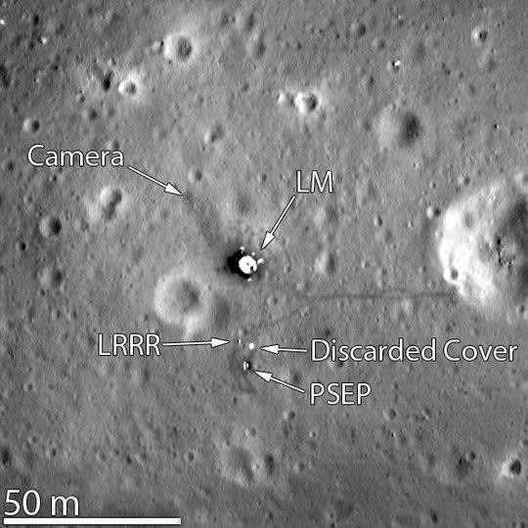

FIG 1.1 MARE TRANQUILITY BASE MAP

## APEX-LUNA THERORY?

* + - * The south pole region features **many craters and basins such as the South Pole–Aitken basin**, which appears to be one of the most fundamental features of the Moon, and mountains.
      * So based on that theory till now the NASA and ISRO hadn’t land and analysis on the souther part of moon .Our main motive is to land the rover on safe side of the tranquility base which is the **00°41′15″N, 23°26′00″E** landing site according to author collins.
      * Upto this date no one has successfully landed the southern Nobile rim 2 surface according to theory of collins.
      * In Exisiting Rover which can capture the photo and then travel some short distance and collect the samples but our rover can map the moon and analysis water structure molecules and travel for long distance with help of three methods of battery system.
      * Our main motive is to analyse and map the Mare Nubium part of the moon which is located in the south west part of moon. According to scientist the nobile rim is the smallest mountain part of the moon containing ice particle. So we developed rover which will be landing on the Tranquility base.00°41′15″N, 23°26′00″E part our rover move towards the south west part of Mare Nubium. Our rover is to analyse the
        + The Deep analysis of water molecule .
        + To map the Nobile rim 2 with the help of Lidar sensor.
        + To travel long distances and provide high efficiency by means of three modes of charging the batteries.

## DOMAINS

This system is based on embedded systems and android systems. Embedded system is used for the identification of potholes and it is interfaced with the android system to provide timely alerts to the user.

## EMBEDDED SYSTEM

An embedded system is a computer system designed to perform one or a few dedicated functions often with real-time computing constraints. It is embedded as part of a complete device often including hardware and mechanical parts. By contrast, a general-purpose computer, such as a personal computer, is designed to be flexible and to meet a wide range of end-user needs. Embedded systems control many devices in common use today.

Embedded systems are controlled by one or more main processing cores that are typically either a Microcontroller or a Digital Signal Processor (DSP). The key characteristic is however being dedicated to handle a particular task, which may require very powerful processors. For example, air traffic control systems may usefully be viewed as embedded, even though they involve mainframe computers and dedicated regional and national networks between airports and radar sites. (Each radar probably includes one or more embedded systems of its own.)

Since the embedded system is dedicated to specific tasks, design engineers can optimize it reducing the size and cost of the product and increasing the reliability and performance. Some embedded systems are mass-produced, benefiting from economies of scale.

Physically, embedded systems range from portable devices such as digital watches and MP3 players, to large stationary installations like traffic lights, factory controllers, or the systems controlling nuclear power plants. Complexity varies from low, with a single microcontroller chip, to very high with multiple units, peripherals and networks mounted inside a large chassis or enclosure.

In general, "embedded system" is not a strictly definable term, as most systems have some element of extensibility or programmability. For example, handheld computers share some elements with embedded systems such as the operating systems and microprocessors which power them, but they allow different applications to be loaded and peripherals to be connected. Moreover, even systems which don't expose programmability as a primary feature generally need to support software updates. On a continuum from "general purpose" to "embedded", large application systems will have subcomponents at most points even if the system as a whole is "designed to perform one or a few dedicated functions” and is thus appropriate to call "embedded".



FIG 1.2 EMBEDDED SYSTEM

## CHARACTERISTICS

* Embedded systems are designed to do some specific task, rather than be a general-purpose computer for multiple tasks. Some also have real-time performance constraints that must be met, for reasons such as safety and usability; others may have low or no performance requirements, allowing the system hardware to be simplified to reduce costs.
* Embedded systems are not always standalone devices. Many embedded systems consist of small, computerized parts within a larger device that serves a more general purpose. For example, the Gibson Robot Guitar features an embedded system for tuning the strings, but the overall purpose of the Robot Guitar is, of course, to play music. Similarly, an embedded system in an automobile provides a specific function as a subsystem of the car itself.
* The program instructions written for embedded systems are referred to as firmware, and are stored in read-only memory or Flash memory chips. They run with limited computer hardware resources: little memory, small or non- existent keyboard and/or screen.

## PROCESSORS IN EMBEDDED SYSTEMS:

Embedded processors can be broken into two broad categories: ordinary microprocessors (μP) and microcontrollers (μC), which have many more peripherals on chip, reducing cost and size. Contrasting to the personal computer and server markets, a fairly large number of basic CPU architectures are used; there are Von Neumann as well as various degrees of Harvard architectures, RISC as well as non-RISC and VLIW; word lengths vary from 4-bit to 64-bits and beyond (mainly in DSP processors) although the most typical remain 8/16-bit. Most architectures come in a large number of different variants and shapes, many of which are also manufactured by several different companies.

## OBJECTIVE OF THE PROJECT:

The project presents and describes a generalizable management-by-objectives framework that can be used for this purpose.

This framework requires

1. formulating indicators and standards,
2. monitoring indicators, and
3. managing to ensure that standards are maintained.

# CHAPTER 2 : LITERATURE SURVEY

## INTRODUCTION TO PATTERN WORK:

**Abstract:**

A rover design study was undertaken for exploration of the Moon. Rovers that have been launched in the past carried a suite of science payload either onboard its body or on the robotic arm’s end. No rover has so far been launched and tasked with “carrying and deploying” a payload on an extraterrestrial surface. This paper describes a lunar rover designed for deploying payload as well as carrying a suite of instruments onboard for conventional science tasks. The main consideration during the rover design process was the usage of existing, in-house technology for development of some rover systems. The manipulation subsystem design was derived from the technology of Light Weight Robot, a dexterous arm originally developed for terrestrial applications. Recent efforts have led to definition of a mission architecture for exploration of the Moon with such a rover. An outline its design, the manipulating arm technology and the design decisions that were made has been presented.

**All Authors :** Aravind Seeni, REC, Bernd Schäfer, Bernhard Rebele, Rainer Krenn

**Published in:** 59th International Astronautical Congress, A.3 Space Exploration Symposium - 2.B Moon Exploration january 2008

## Next Generation Rover for Lunar Exploration

**Abstract :**

A bright light appears in the starry blackness above the stark lunar landscape as a cargo lander fires its rockets for descent to the surface. Waiting in the semi- twilight of the lunar south pole, a transport vehicle stands ready to assist the offloading and deployment of the much-needed power system and science laboratory. Meanwhile, another vehicle with a regolith moving blade attached, has just completed the excavation of the new home for the power system on the rim of Shackleton crater. As the Lander touches down several hundred meters away, the first vehicle turns and begins rolling toward it… As NASA further refines its plans for the return of humans to the lunar surface, it is becoming very clear that surface mobility will be critical to outpost buildup and exploration activities. In analyzing lunar surface scenarios, NASA’s Lunar Architecture Team (LAT) identified vehicle chassis potentially suited for lunar surface operations during their Phase I study. These chassis range from small (100 kg) crew aids to very large carriers capable of moving an entire lander. To better understand the technologies and operations for this range of vehicles, NASA’s Exploration Technology Development Program is investing in a broad range of surface mobility projects.

**All Authors :** Dan A. Harrison Robert Ambrose Bill Bluethmann Lucien Junkin

**Published in :** IEEEAC paper #1196, Final, December 5, 2007

# Design of a Day/Night Lunar Rover

## Abstract :

The pair of lunar rovers discussed in this report will return video and state data to various ventures, including theme park and marketing concerns, science agencies, and educational institutions. The greatest challenge accepted by the design team was to enable operations throughout the extremely cold and dark lunar night, an unprecedented goal in planetary exploration. This is achieved through the use of the emerging technology of Alkali Metal Thermal to Electric Converters (AMTEC), provided with heat from a innovative beta-decay heat source, Krypton-85 gas. Although previous space missions have returned still images, our design will convey panoramic video from a ring of cameras around the rover. A six-wheel rocker bogie mechanism is implemented to propel the rover. The rovers will also provide the ability to safeguard their operation to allow untrained members of the general public to drive the vehicle. Additionally, scientific exploration and educational outreach will be supported with a user operable, steerable and zoomable camera.

**All Authors :** Dr. William L. Whittaker, Instructor.

**Published in :** The Robotics Institute Carnegie Mellon University Pittsburgh, Pennsylvania 15213 June 1995

## 4. A New type design of lunar rover suspension structure and its neural network control system

**Abstract :**

Suspension design is one of the important parts in the research ﬁeld on lunar rover mobile system. To conduct

detailed dynamic analysis on the new type of suspension, this paper presents a new type of six link double ring lunar

rover suspension model based on ADAMS virtual simulation software. And, this paper designs the lunar rover path tracking

neural network controller. Simulation and test results show that the new lunar rover suspension has strong ground adaptability,

obstacle surmounting capability and anti-overturning ability compared to classic suspension, and the neural network controller

based on the new suspension has good tracking ability. The research results provide a reference for autonomous navigation

control on lunar rover.

**All Authors :** Lu Yang Bowen Cai

Mississippi State University Ronghui Zhang

Kening Li

**Published in :** July 2018 Journal of Intelligent and Fuzzy Systems 35(4):1-13

## SUMMARY

In this chapter, we had reviewed the previous works depicted by different authors in various national and international journals on our topic of interest. The methods and the concepts used to arrive at better results by different authors is deliberately studied. The advantages and disadvantages of each method is discussed clearly.

# CHAPTER 3 : SYSTEM ANALYSIS

## EXISTING SYSTEM

* + 1. **DISADVANTAGES**
       - Controlling problem
       - Wastage of electricity
       - Dust problem
       - Didn’t possible to land on southern part of moon

## PROPOSED SYSTEM

* The objective of this project is to develop and implement an manaual and semi automated rover which can imporve the controlling problem our rover is made for an austorner commanding rover. This design is to detect the obstacles using ultrasonic laser sensor, the laser will fall on object and it will be detected using waves, Actually our main plan is to controll the rover properly, so by using above follwing techinques we can avoid those problems mentioned above.
* In addition we also have water moleule detection which can detect the presence of water with the help of Digital microscope and analysis its location with coordinates.
* In addition we also have an backup and powerful battery source, we are using 32 v battery to run our rover which can be recharged by means of two ways one way is by means of solar pannel and other way is by means of thermoelectic generator and also we have two batteries for backup purpose.
* So based on that theory till now the NASA and ISRO hadn’t land and analysis on the souther part of moon .Our main motive is to land the rover on safe side of the tranquility base which is the 00°41′15″N, 23°26′00″E landing site according to author collins. So our Apex-luna rover will travel to the Mare Nubium Nobile rim 2, 70 degree longitude towards south west of the lunar which is nearest to the tranquility base apollo lander so it is simply way to land the Mission..
* For long travel we are having a powefull battery backups, so our project can be an best solution to sort out the exisiting problems.

## ADVANTAGES

* + - * This project saves electricity.
      * Contolling part is maual and semi auto so it can be the easiest way to contol the rover.
      * Thus it helps in water molecule detection.
      * This project is also helpful to acoid dust particles and measure the obstacle didtance and capture a video on the basis.

## SUMMARY

In this chapter, the system analysis is given. The existing method is stated. The detailed explanation of the proposed system is given along with the advantages.

# CHAPTER 4 : SYSTEM DESIGN

## 4.1 BLOCK DIAGRAM

A block diagram is a diagram of a system in which the principal parts or functions are represented by blocks connected by lines that show the relationships.

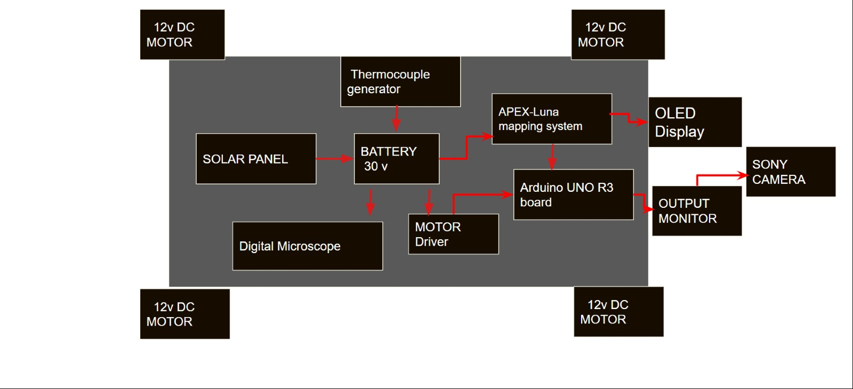

FIG 1.3 BLOCK DIAGRAM

# CHAPTER 5 : HARDWARE DESCRIPTION

## MICROCONTROLLER

## GENERAL DESCRIPTION

Arduino is an open-source project that created microcontroller-based kits for building digital devices and interactive objects that can sense and control physical devices. The project is based on microcontroller board designs, produced by several vendors, using various microcontrollers. These systems provide sets of digital and analog input/output (I/O) pins that can interface to various expansion boards (termed shields) and other circuits. The boards feature serial communication interfaces, including Universal Serial Bus (USB) on some models, for loading programs from personal computers. For programming the microcontrollers, the Arduino project provides an integrated development environment (IDE) based on a programming language named Processing, which also supports the languages C and C++.

## PRODUCT DESCRIPTION

Arduino Uno is a microcontroller board based on the ATmega328P. It has 14 digital input/output pins (of which 6 can be used as PWM outputs), 6 analog inputs, a 16 MHz quartz crystal, a USB connection, a power jack, an ICSP header and a reset button. It contains everything needed to support the microcontroller; simply connect it to a computer with a USB cable or power it with an AC-to-DC adapter. Arduino Uno has a number of facilities for communicating with a computer, another Arduino board, or other microcontrollers.

## HARDWARE NEEDED

To burn a new version of the Arduino bootloader to your UNO, you'll need an AVR ISP Compatible downloader.

## Using an AVR ISP (In System Programmer)

* + - * Your Arduino UNO (to program)
      * An AVR Programmer such as the [AVR Pocket Programmer](http://www.sparkfun.com/products/9825)
      * An AVR Programming Cable (the pocket programmer comes with one)

If you have extra Arduino boards, but no ISP programmer, SparkFun.com has a cool tutorial on how to flash a bootloader using an Arduino as an ISP.

## Using another Arduino as an ISP

* + - * Your Arduino UNO (to program)
      * A Working Arduino (doesn't matter what kind)
      * Some Male-to-Male Jumper Cables

For instructions on this method, take a look at the SparkFun.com website: <http://www.sparkfun.com/tutorials/247>

## FEATURES

* + - * Microcontroller: ATmega328P
      * Operating voltage: 5V
      * Input voltage: 7-12V
      * Flash memory: 32KB
      * SRAM: 2KB
      * EEPROM: 1KB

## APPLICATIONS

* + - * Real time biometrics
      * Robotic applications

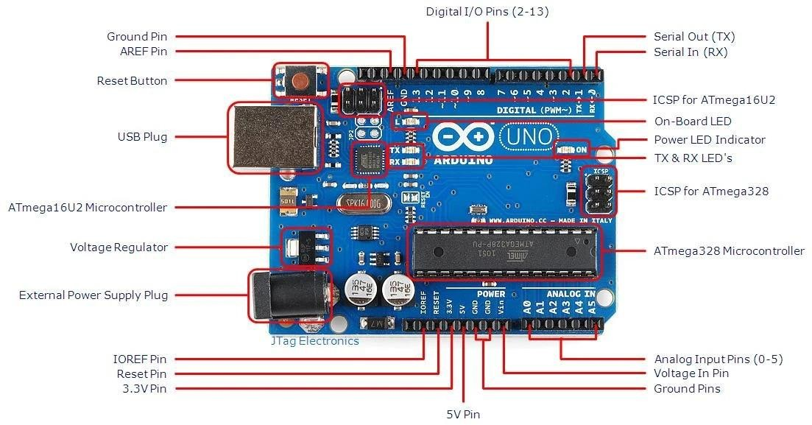

FIG 1.4 ARDUINO UNO

## POWER SUPPLY

## 32-VOLT BATTERY:

A battery is a device that converts chemical energy contained within its active materials directly into electric energy by means of an electrochemical oxidation- reduction (redox) reaction.

In our project we are using 3 batteries for recharging purposes which enhances and gives more capacity to travel long distance.

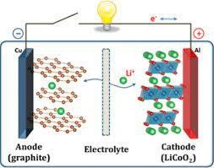

FIG 1.5 Battery

## SOLAR PANNEL:

* A solar panel is actually a collection of solar (or photovoltaic) cells, which can be used to generate electricity through photovoltaic effect. These cells are arranged in a grid-like pattern on the surface of solar panels.
* The design and installation of PV systems on a large scale enable us to move away from other polluting and unsustainable energy sources. Since the solar industry is growing, that means that the need for skilled workers is also growing!
* Solar panels work by absorbing sunlight and converting it into direct current (DC) electricity. This DC electricity is then converted into alternating current (AC) electricity using an inverter, as AC electricity is the type used by most electronic devices and appliances.
* When it comes to wear-and-tear, these panels are very hardy. Solar panels wear out extremely slow. In a year, their effectiveness decreases only about one to two per cent (at times, even lesser). Each solar cell is made up of two slices of semi-conducting material (often silicon) which has been ‘doped’ with other materials to give each slice either a positive or a negative charge. The top slice is usually seeded with phosphorous to add electrons and create a negative charge, while the bottom slice has boron added, resulting in fewer electrons and a positive charge. Each layer includes metal conductive plates on one side, and the junction between these layers is where the electric field is created.
* When a photon of sunlight strikes the cell it knocks electrons loose from their atoms. These freed electrons are then able to flow between the conductors and through the circuit to generate electricity. This direct current electricity flows in one direction through the circuit, from the negative to the positive side. However, the current needs to be passed through an inverter to convert it into an alternating current (AC) electricity, which can then go to the Grid, be used in home solar systems or to power business.
* AC power pushes and pulls the electrons, periodically reversing the direction of the flow. This type of current is created with an inverter, which also provides system statistics and ground fault protection. Micro-inverters that optimise each solar panel in a system can improve the output of the entire system as a problematic panel (such as one that is dirty or in the shade) will not drag down the performance of the entire solar array.

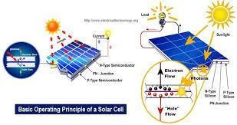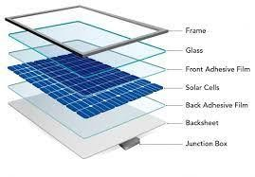

FIG 1.6 SOLAR PANNEL DIAGRAM

## THERMOELECTRIC GENERATOR:

* Thermoelectric energy harvesting mainly depends on the operation of the thermoelectric generator (TEG). A TEG converts heat directly into electrical energy according to the Seebeck effect. In this case, the motion of charge carriers (electrons and holes) leads to a temperature difference across this device. Its operation is described in Section 2.3. Furthermore, the thermoelectric energy harvesting system can generate power from hundreds of μW to mW for different sensors and transmitters.
* In the last decades, the specialists’ attention has been focused on the development of green energy technology to decrease fossil fuel utilisation and greenhouse gas emissions. A thermoelectric harvester produces green energy for energy harvesting with a multitude of advantages: maintenance-free, because of the use of highly reliable and compact solid-state device; silent and quiet; highly efficient in environmental terms because the heat is harvested from waste heat sources and converted into electricity; operation with high maximum temperatures (up to 250°C); useful scalable applications configured to harvest wide amounts of energy when necessary; possibility to harvest power from both hot surface or cold surface; green energy behaviour, being eco-friendly. A TEG device produces energy without using fossil

fuel, leading to a reduction of greenhouse gas emissions.

* Unlike thermodynamic PV systems or conventional heat engines (Rankine, Stirling), the energy conversion efficiency of the TEG is limited to about 5–15% . The temperature difference across the TEG system and the dimensionless thermoelectric figure-of-merit ( ZTZT ) have a major impact on the energy conversion efficiency . It is desirable to obtain the maximum electric output power and efficiency when a TEG system operates. In case of waste heat recovery applications , only electric output power is significant and the heat not recovered is lost . Considering that thermal energy harvesting has a reduced efficiency (5–6%), this could represent a major barrier for its extensive utilisation. An improvement in the TEG efficiency bigger than 10% has been lately obtained due to the progress of new thermoelectric materials .

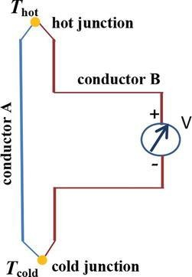

FIG 1.7 THERMOELECTRIC GENERATOR

## MOTOR CIRCUIT CONNECTION

* We are using 12 v dc motor which is connected in series the right part the front and back connected as series, In the left part the fornt and back wheel is connected as series then the motor wires connected to the l298n motor driver.
* The speed of a DC motor can be controlled by changing its input voltage. A widely used technique to accomplish this is Pulse Width Modulation (PWM).
* PWM is a technique in which the average value of the input voltage is adjusted by sending a series of ON-OFF pulses. This average voltage is proportional to the width of the pulses, which is referred to as the Duty Cycle.
* The higher the duty cycle, the higher the average voltage applied to the DC motor, resulting in an increase in motor speed. The shorter the duty cycle, the lower the average voltage applied to the DC motor, resulting in a decrease in motor speed.
* The image below shows PWM technique with various duty cycles and average voltages.

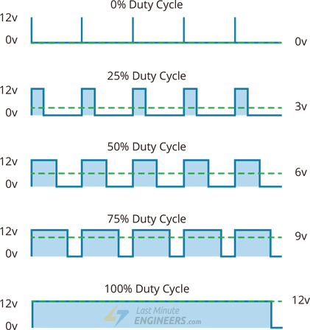

## FEATURES

* + - * Can be used to run Two DC motors with the same IC.
      * Speed and Direction control is possible
      * Motor voltage Vcc2 (Vs): 4.5V to 36V
      * Maximum Peak motor current: 1.2A
      * Maximum Continuous Motor Current: 600mA
      * Supply Voltage to Vcc1(vss): 4.5V to 7V

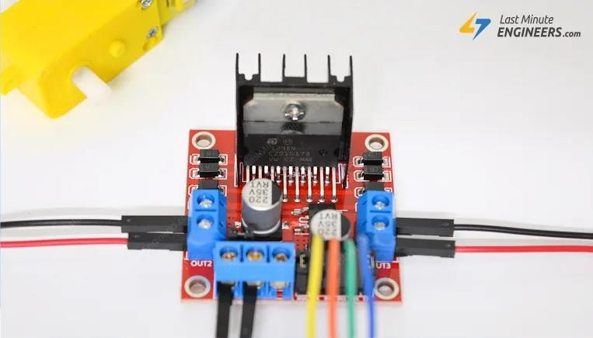

FIG 1.8 L298N MOTOR DRIVER MODULE

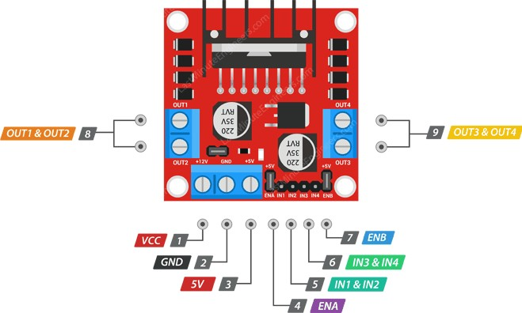

FIG 1.9 L293D PIN CONFIGURATION

## DIGITAL MICROSCOPE:

A digital microscope is a microscope that uses a digital camera instead of an eyepiece. Digital microscopes connect to a computer monitor to show the results in real time.

The most obvious advantage is the ergonomics of the instrument. Because the image of the sample is displayed on a monitor, users are able to view them immediately and analyze the sample image using software while sitting in a

comfortable and relaxed upright position.

The Input and out functions and in this aspect, the digital microscope is made of two major parts; The hardware – this is majorly the analog part of the microscope, with a light source, the analog microscope, a camera, and the camera components. the Camera replaces the eyepiece of the traditional microscope.

A Digital microscope which is used to detect water molecules with the help of OpenCV library package implemented in JavaScript.

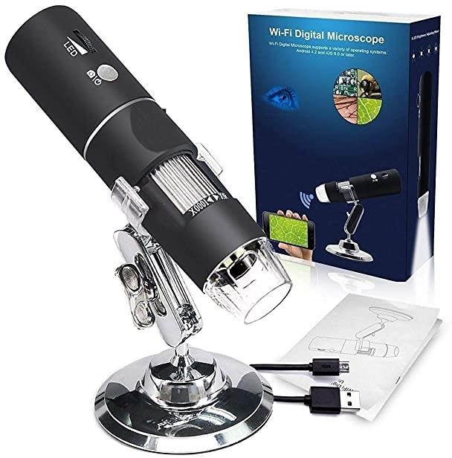

FIG 2.0 DIGITAL MICROSCOPE

## ULTRASONIC LASER SENSOR

* Ultrasonic sensors work by emitting sound waves at a frequency too high for humans to hear. They then wait for the sound to be reflected back, calculating distance based on the time required. This is similar to how

radar measures the time it takes a radio wave to return after hitting an object.

* While some sensors use a separate sound emitter and receiver, it’s also possible to combine these into one package device, having an ultrasonic element alternate between emitting and receiving signals. This type of sensor can be manufactured in a smaller package than with separate elements, which is convenient for applications where size is at a premium.
* While radar and ultrasonic sensors can be used for some of the same purposes, sound-based sensors are readily available—they can be had for just a couple dollars in some cases—and in certain situations, they may detect objects more effectively than radar.
* For instance, while radar, or even light-based sensors, have a difficult time correctly processing clear plastic, ultrasonic sensors have no problem with this. In fact, they’re unaffected by the color of the material they are sensing.
* On the other hand, if an object is made out of a material that absorbs sound or is shaped in such a way that it reflects the sound waves away from the receiver, readings will be unreliable.
* If you need to measure the specific distance from your sensor, this can be calculated based on this formula:
* Distance = ½ T x C
* (T = Time and C = the speed of sound)
* At 20°C (68°F), the speed of sound is 343 meters/second (1125 feet/second), but this varies depending on temperature and humidity.
* Specially adapted ultrasonic sensors can also be used underwater. The speed of sound, however, is 4.3 times as fast in water as in air, so this calculation must be adjusted significantly.

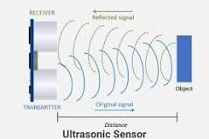

FIG 2.1 ULTRASONIC SENSOR

## PIN CONFIGURATION

|  |  |  |
| --- | --- | --- |
| **Pin Number** | **Pin Name** | **Description** |
| 1 | Vcc | The Vcc pin powers the sensor, typically with +5V |
| 2 | Trigger | Trigger pin is an Input pin. This pin has to be kept high for 10us to initialize measurement by sending  US wave. |
| 3 | Echo | Echo pin is an Output pin. This pin goes high for a period of time which will be equal to the time taken for the US wave to return  back to the sensor. |
| 4 | Ground | This pin is connected to the Ground of the system. |

* + 1. **ULTRASONIC SENSOR IN A SENSOR SHIELD MODULE**

Arduino Sensor Shield is a board used to connect sensors, servos, LCD with the Arduino Board without the requirement of soldering.

Using Arduino Board separately you’ll find a few of 5V and GND connections. Arduino Sensor Shield gives you the ability of dedicated one 5V and GND connection for every Arduino signal pin.

Arduino.cc introduced the two versions of Arduino Sensor Shield i.e. V4 the old one and V5 the newer one. Both boards come with similar important connections, however, they appear different.

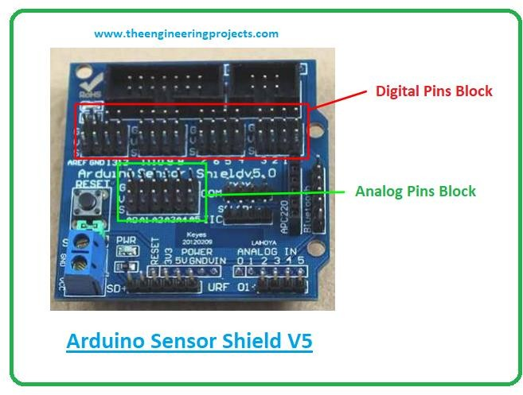

FIG 2.3 ULTRASONIC SENSOR IN A SENSOR SHIELD MODULE

The V5 latest sensor shield comes with an external power connector, helping you get rid of the overloading of the Arduino board while working with too many actuators and sensors.

The 3-way male pin header is used to connect servo motors with the Arduino Board. This is a plug and play device. You can read data from the sensors connected with the shield and use it to drive servo motors with the Arduino boards.

## 12 V DC MOTOR

An electric motor is an electrical machine that converts electrical energy into mechanical energy. Most electric motors operate through the interaction between the motor's magnetic field and electric current in a wire winding to generate force in the form of torque applied on the motor's shaft. An electric generator is mechanically identical to an electric motor, but operates with a reversed flow of power, converting mechanical energy into electrical energy.

Electric motors can be powered by direct current (DC) sources, such as from batteries, or rectifiers, or by alternating current (AC) sources, such as a power grid, inverters or electrical generators.

Electric motors may be classified by considerations such as power source type, construction, application and type of motion output. They can be powered by AC or DC, be brushed or brushless, single-phase, two-phase, or three-phase, axial or radial flux, and may be air-cooled or liquid-cooled.

Standardized motors provide convenient mechanical power for industrial use. The largest are used for ship propulsion, pipeline compression and pumped- storage applications with output exceeding 100 megawatts.

High Torque Rated Voltage Current : DC 12V Speed: 4000RPM Motor

Shaft Diameter: 3.17mm Mounting

Diameter of the Motor: 36mm Length of the Motor (Body): 50mm Length of Shaft: 16mm

## FEATURES

**12 Volt DC Motor – 200 RPM Operating Voltage(V): 12.**

## Rated Speed (RPM): 200. Rated Torque(kg-cm): 1.5.

**Stall Torque(kg-cm): 5.4. Load Current (A): 0.3.**

## No Load Current (A): 0.06.

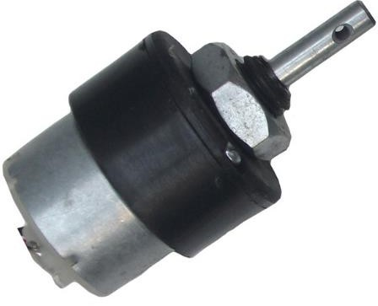

FIG 2.4 DC MOTOR

## OLED DISPLAY

The basic OLED structure is simple - an organic emitter placed between two electrodes. But in order to create efficient and long-lasting devices, commercial OLEDs use several intermediate layers, like electron transport and blocking layers. The whole organic stack is placed between the electrodes, and this whole structure is deposited on the substrate (glass or plastic) and the display backplane (driver electronics). Some OLED displays on the market make use of dozens of different layers, one on top of the other.

Basic structure of an OLED (source: OLED-Info) OLED Production Processes

Currently, almost all OLED displays on the market are produced using an evaporation-based process, in which the OLED materials are deposited in a vacuum chamber. This has proven to be a great way to make OLEDs, but the process has its limitations - mainly material waste and high cost.

Companies are now developing next-generation deposition processes to enable more efficient production. One example is ink-jet printing, which makes use of soluble OLED inks that can be deposited using huge printers. This process is faster than the current evaporation process, and has almost no waste of materials. While there are still some challenges to overcome, it is expected that printed OLEDs will start entering the market soon - starting with TVs and monitor panels.

OLED Emitter Material Generations

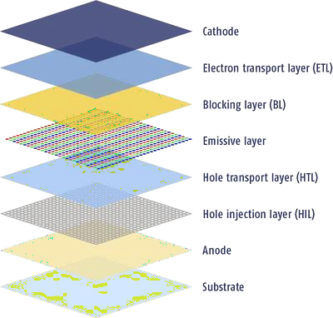

The first OLED devices used so-called fluorescence emitters (1st-gen emitters). These are relatively stable and easy to produce compounds, but their internal efficiency is limited to around 25% - only a quarter of the energy is translated into light.

2nd-generation OLED emitters, called phosphorescence OLEDs, dope these emitters with heavy metals (usually iridium) which enables an internal efficiency of up to 100%. As of today, very efficient red and green phosphorescence OLEDs are available on the market and most OLED displays make use of these emitters to create highly efficient emitters.

An efficient and long-lasting blue emitter material has proven extremely hard to produce, and companies are still struggling to develop this material. Any much- anticipated success in doing so would surely have a dramatic effect on the power efficiency of OLED displays. While one option is to develop a blue

phosphorescence OLED, there are also 3rd and even 4th-generation materials (TADF and Hyperfluorescence) OLED technologies which show great promise.

## FEATURES

* very saturated, vivid colors.
* deepest black, highest contrast ratio.
* a wide viewing angle (180°)
* low power consumption.
* extremely thin form factor, flexible.
* response time in microseconds for very crisp motion picture quality and 3D applications.

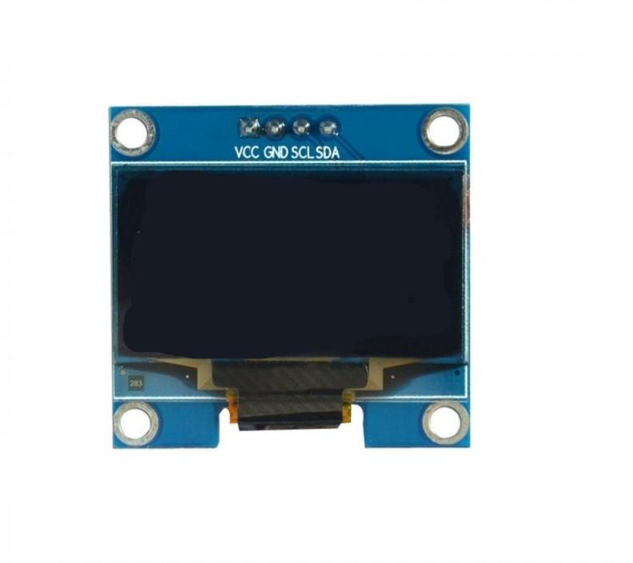

FIG 2.5 OLED DISPLAY

## AMPLIFIER:

**Amplifier** is the generic term used to describe a circuit which produces and increased version of its input signal. However as we will see in this introduction to the amplifier tutorial, not all amplifier circuits are the same as they are classified according to their circuit configurations and modes of operation.

In “Electronics”, small signal amplifiers are commonly used devices as they have the ability to amplify a relatively small input signal, for example from a Sensor such as a photo-device, into a much larger output signal to drive a relay, lamp or loudspeaker for example.

There are many forms of electronic circuits classed as amplifiers, from Operational Amplifiers and Small Signal Amplifiers up to Large Signal and Power Amplifiers. The classification of an amplifier depends upon the size of the signal, large or small, its physical configuration and how it processes the input signal, that is the relationship between input signal and current flowing in the load.

The type or classification of an Amplifier is given in the following table.

## Introduction to the Amplifier – Classification Amplifier

|  |  |  |  |
| --- | --- | --- | --- |
|  |  |  |  |
| Small Signal | Common Emitter | Class A Amplifier | Direct Current (DC) |
| Large Signal | Common Base | Class B Amplifier | Audio Frequencies (AF) |
|  | Common Collector | Class AB Amplifier | Radio Frequencies (RF) |
|  |  | Class C Amplifier | VHF, UHF and SHF  Frequencies |

Amplifiers can be thought of as a simple box or block containing the amplifying device, such as a Bipolar Transistor, Field Effect Transistor or Operational Amplifier, which has two input terminals and two output terminals (ground being common) with the output signal being much greater than that of the input signal as it has been “Amplified”.

## FEATURES

* Gain, the ratio between the magnitude of output and input signals.
* Bandwidth, the width of the useful frequency range.
* Efficiency, the ratio between the power of the output and total power consumption.

## APPLICATIONS

An Amplifier or an operational amplifier (op-amp) circuit is commonly used in the automation, control and other electronic circuits for marine applications. The applied input signal is usually a voltage or a current signal. The purpose of an amplifier is to produce an output signal larger than that of the input signal.

## DC-DC BOOSTER

A boost converter (step-up converter) is a DC-to-DC power converter that steps up voltage (while stepping down current) from its input (supply) to its output (load). It is a class of switched-mode power supply (SMPS) containing at least two semiconductors (a diode and a transistor) and at least one energy storage element: a capacitor, inductor, or the two in combination. To reduce voltage ripple, filters made of capacitors (sometimes in combination with inductors) are normally added to such a converter's output (load-side filter) and input (supply- side filter).

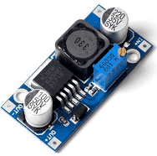

FIG 2.7 DC-DC BOOSTER

## FEATURES

DC-to-DC converters are devices that temporarily store electrical energy for the purpose of converting direct current (DC) from one voltage level to another. In automotive applications, they are an essential intermediary between systems of different voltage levels throughout the vehicle.

## APPLICATIONS

Some key applications where DC/DC converters are employed extensively include renewable energy integration, medical devices, vehicles, smart lighting, and other small-scale electronic appliances.

## SENSOR SHIELD V5:

communication module interface, SD Card communication module interface and so on, more convenient.

Sensor Shield allows you to connect to various modules like sensors, servos, relays, buttons, potentiometers and many more directly to your Arduino through this Sensor Shield.

Each functional module has buckled port with VCC, GND, and Output, which has the corresponding port on the Sensor Shield, connected with a plain 2.54mm dual-female cable you may start playing already. Buckled brick cables are like cement for bricks, make the connections easier, secure and more professional looking.

You can easily connect with usual analog sensors by using this expansion board, such as ray sensor. If you support by this expansion board and the corresponding circuit module, you only need to combine Arduino and sensors module by using special cables, because concrete circuit details achieve by corresponding sensors module, so you only need to consider that how to read data coming from the sensor by the program in Arduino.

For Arduino beginners, you do not have a headache for the cumbersome and complex circuit connection, the sensor extends the true sense of the board to simplify the circuit which can easily connect the commonly used sensor, a sensor requires only a common 3P sensor cable (regardless of digital cable and analog cable), after the completion of the circuit connection, the preparation of the corresponding Arduino program downloaded to the Arduino Duemilanove controller reads the sensor data, or receive wireless module to return data after computing the final easy to complete your own interactive works.

This module is compatible with following Arduino Boards, click on the name below to buy them

Arduino UNO

Arduino DUE

## FEATURES

* Retain the merits of the V4.0 version
* Laminated design
* PCB immersion gold processing technology
* IIC interface
* Bluetooth module communication interface
* SD card module communication interface
* APC220 wireless rf modules communication interface
* RB URF v1.1 ultrasonic sensors interface
* 12864 LCD string of line and parallel interface
* 32 servo controller interface

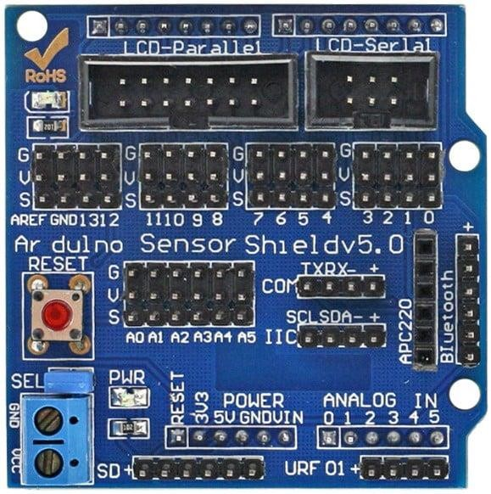

FIG 2.8 SENSOR SHEILD V5

## LED STRIP

The Bright 12V Cold White LED Strip has high intensity and reliability. It has a significantly longer life span of around 50,000 hours than ordinary LED strips available in the market and therefore it can be used for applications where long- life performance is required.

This 10 centimeter LED strip with around 6 LEDs on strip operates at [12V at 2A](https://robu.in/product/orange-12v-2a-power-supply-with-5-5mm-dc-plug-adapter/) [DC supply](https://robu.in/product/orange-12v-2a-power-supply-with-5-5mm-dc-plug-adapter/). The Strip has soldered endpoints from both ends to connect the strip conveniently.

The flexible ribbon is very easy for curving around bends and for completely smooth and even light spread, solving the uneven luminous problem. This LED strip has the advantage of Ultra-bright but running at low-temperature low power consumption. The strip comes with 10cm self-adhesive to easy install.

## FEATURES

* Long life span 50,000 hours
* Soldered by pieces, packed with 10 centimeter.
* Flexible ribbon for curving around bends
* Completely smooth and even light spread, solving the uneven luminous problem
* Ultra-bright but running at low temperature
* Low power consumption

## APPLICATIONS

* Ideal for decoration of building outlines, landscape illumination, amusement themes,
* Holiday light sculpture, decorative figure, active signs, displays, shop windows
* And storefronts, bar, nightclub, street, sidewalk, deck, park, porch, staircase, railing, ceiling, or driveway.

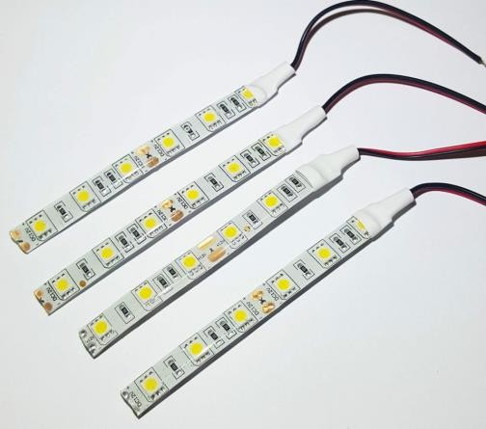

FIG 2.9 12V LED STRIP

## SUMMARY

In this chapter, the system specifications are explained. It includes the hardware environment:Microcontroller, Power supply, Driver Circuit, LDR Sensor, Gas Sensor, Water Pump Motor, LCD Display, Soil Moisture Sensor, DC Motor, IOT Module and LED Strips.

# CHAPTER 6 : SOFTWARE DESCRIPTION

## EMBEDDED C

High-level language programming has long been in use for embedded-systems development. However, assembly programming still prevails, particularly for digital-signal processor (DSP) based systems. DSPs are often programmed in assembly language by programmers who know the processor architecture inside out. The key motivation for this practice is performance, despite the disadvantages of assembly programming when compared to high-level language programming.

If the video decoding takes 80 percent of the CPU-cycle budget instead of 90 percent, for instance, there are twice as many cycles available for audio processing. This coupling of performance to end-user features is characteristic of many of the real-time applications in which DSP processors are applied. DSPs have a highly specialized architecture to achieve the performance requirements for signal processing applications within the limits of cost and power consumption set for consumer applications. Unlike a conventional Load-Store (RISC) architecture, DSPs have a data path with memory-access units that directly feed into the arithmetic units. Address registers are taken out of the general-purpose register file and placed next to the memory units in a separate register file.

A further specialization of the data path is the coupling of multiplication and addition to form a single cycle Multiply-accumulate unit (MAC). It is combined with special-purpose accumulator registers, which are separate from the general-purpose registers. Data memory is segmented and placed close to the MAC to achieve the high bandwidths required to keep up with the streamlined data path. Limits are often placed on the extent of memory- addressing operations. The localization of resources in the data path saves many data movements that typically take place in Load-Store architecture.

The most important, common arithmetic extension to DSP architectures is the handling of saturated fixed-point operations by the arithmetic unit. Fixed-point arithmetic can be implemented with little additional cost over integer arithmetic. Automatic saturation (or clipping) significantly reduces the number of control-flow instructions needed for checking overflow explicitly in the program. Changes in technological and economic requirements make it more expensive to continue programming DSPs in assembly. Staying with the mobile phone as an example, the signal-processing algorithms required become increasingly complex. Features such as stronger error correction and encryption must be added. Communication protocols become more sophisticated and require

much more code to implement. In certain markets, multiple protocol stacks are implemented to be compatible with multiple service providers. In addition, backward compatibility with older protocols is needed to stay synchronized with provider networks that are in a slow process of upgrading.

Today, most embedded processors are offered with C compilers. Despite this, programming DSPs is still done in assembly for the signal processing parts or, at best, by using assembly-written libraries supplied by manufacturers. The key reason for this is that although the architecture is well matched to the requirements of the signal-processing application, there is no way to express the algorithms efficiently and in a natural way in Standard C. Saturated arithmetic.

For example, it is required in many algorithms and is supplied as a primitive in many DSPs. However, there is no such primitive in Standard C. To express saturated arithmetic in C requires comparisons, conditional statements, and correcting assignments. Instead of using a primitive, the operation is spread over a number of statements that are difficult to recognize as a single primitive by a compiler.

## DESCRIPTION

Embedded C is designed to bridge the performance mismatch between Standard C and the embedded hardware and application architecture. It extends the C language with the primitives that are needed by signal-processing applications and that are commonly provided by DSP processors. The design of the support for fixed-point data types and named address spaces in Embedded C is based on DSP-C. DSP-C [1] is an industry-designed extension of C with which experience was gained since 1998 by various DSP manufacturers in their compilers. For the development of DSP-C by ACE (the company three of us work for), cooperation was sought with embedded-application designers and DSP manufacturers.

The Embedded C specification extends the C language to support freestanding embedded processors in exploiting the multiple address space functionality, user-defined named address spaces, and direct access to processor and I/O registers. These features are common for the small, embedded processors used in most consumer products. The features introduced by Embedded C are fixed-point and saturated arithmetic, segmented memory spaces, and hardware I/O addressing. The description we present here addresses the extensions from a language-design perspective, as opposed to the programmer or processor architecture perspective.

## MULTIPLE ADDRESS SPACES

Embedded C supports the multiple address spaces found in most embedded systems. It provides a formal mechanism for C applications to directly access (or map onto) those individual processor instructions that are designed for optimal memory access. Named address spaces use a single, simple approach to grouping memory locations into functional groups to support MAC buffers in DSP applications, physical separate memory spaces, direct access to processor registers, and user-defined address spaces.

The Embedded C extension supports defining both the natural multiple address space built into a processor's architecture and the application-specific address space that can help define the solution to a problem.

Embedded C uses address space qualifiers to identify specific memory spaces in variable declarations. There are no predefined keywords for this, as the actual memory segmentation is left to the implementation. As an example, assume that **X** and **Y** are memory qualifiers. The definition:

X int a[25] ;

Means that **a** is an array of 25 integers, which is located in the **X** memory. Similarly (but less common):

X int * Y p ;

Means that the pointer **p** is stored in the **Y** memory. This pointer points to integer data that is located in the **X** memory. If no memory qualifiers are used, the data is stored into unqualified memory.

For proper integration with the C language, a memory structure is specified, where the unqualified memory encompasses all other memories. All unqualified pointers are pointers into this unqualified memory. The unqualified memory abstraction is needed to keep the compatibility of the **void \*** type, the **NULL** pointer, and to avoid duplication of all library code that accesses memory through pointers that are passed as parameters.

## NAMED REGISTERS

Embedded C allows direct access to processor registers that are not addressable in any of the machine's address spaces. The processor registers are defined by the compiler-specific, named-register, storage class for each supported processor. The processor registers are declared and used like conventional C variables (in many cases volatile variables). Developers using Embedded C can now develop their applications, including direct access to the condition code register and other processor-specific status flags, in a high-level language, instead of inline assembly code.

Named address spaces and full processor access reduces application dependency on assembly code and shifts the responsibility for computing data types, array and structure offsets, and all those things that C compilers routinely and easily do from developers to compilers.

## I/O HARDWARE ADDRESSING

The motivation to include primitives for I/O hardware addressing in Embedded C is to improve the portability of device-driver code. In principle, a hardware device driver should only be concerned with the device itself. The driver operates on the device through device registers, which are device specific. However, the method to access these registers can be very different on different systems, even though it is the same device that is connected. The I/O hardware access primitives aim to create a layer that abstracts the system-specific access method from the device that is accessed. The ultimate goal is to allow source- code portability of device drivers between different systems. In the design of the I/O hardware-addressing interface, three requirements needed to be fulfilled:

* + - 1. The device-drive source code must be portable.
      2. The interface must not prevent implementations from producing machine code that is as efficient as other methods.
      3. The design should permit encapsulation of the system-dependent access method.

The design is based on a small collection of functions that are specified in the <iohw.h> include file. These interfaces are divided into two groups; one group provides access to the device, and the second group maintains the access method abstraction itself.

To access the device, the following functions are defined by Embedded C:

unsigned int iord( ioreg_designator );

void iowr( ioreg_designator, unsigned int value ); void ioor( ioreg_designator, unsigned int value ); void ioand( ioreg_designator, unsigned int value );

void ioxor( ioreg_designator, unsigned int value );

These interfaces provide read/write access to device registers, as well as typical methods for setting/resetting individual bits. Variants of these functions are defined (with **buf** appended to the names) to access arrays of registers. Variants are also defined (with l appended) to operate with **long** values.

All of these interfaces take an I/O register designator **ioreg_designator** as one of the arguments. These register designators are an abstraction of the real registers provided by the system implementation and hide the access method from the driver source code. Three functions are defined for managing the I/O register designators. Although these are abstract entities for the device driver, the driver does have the obligation to initialize and release the access methods. These functions do not access or initialize the device itself because that is the task of the driver. They allow, for example, the operating system to provide a memory mapping of the device in the user address space.

void iogroup_acquire( iogrp_designator ); void iogroup_release( iogrp_designator );

void iogroup_map( iogrp_designator, iogrp_designator );

The **iogrp_designator** specifies a logical group of I/O register designators; typically this will be all the registers of one device. Like the I/O register designator, the I/O group designator is an identifier or macro that is provided by the system implementation. The map variant allows cloning of an access method when one device driver is to be used to access multiple identical devices.

## EMBEDDED C PORTABILITY

By design, a number of properties in Embedded C are left implementation defined. This implies that the portability of Embedded C programs is not always guaranteed. Embedded C provides access to the performance features of DSPs. As not all processors are equal, not all Embedded C implementations can be equal For example, suppose an application requires 24-bit fixed-point arithmetic and an Embedded C implementation provides only 16 bits because that is the native size of the processor. When the algorithm is expressed in Embedded C, it will not produce outputs of the right precision.

In such a case, there is a mismatch between the requirements of the application and the capabilities of the processor. Under no circumstances, including the use of assembly, will the algorithm run efficiently on such a processor. Embedded C cannot overcome such discrepancies.

Yet, Embedded C provides a great improvement in the portability and software engineering of embedded applications. Despite many differences between performance-specific processors, there is a remarkable similarity in the special- purpose features that they provide to speed up applications.

Writing C code with the low-level processor-specific support may at first appear to have many of the portability problems usually associated with assembly code. In the limited experience with porting applications that use Embedded C extensions, an automotive engine controller application (about 8000 lines of source) was ported from the eTPU, a 24-bit special-purpose processor, to a general-purpose 8-bit Freescale 68S08 with about a screen full of definitions put into a single header file.

The porting process was much easier than expected. For example, variables that had been implemented on the processor registers were ported to unqualified memory in the general-purpose microprocessor by changing the definitions in the header definition and without any actual code modifications.

The exercise was to identify the porting issues and it is clear that the performance of the special-purpose processor is significantly higher than the general-purpose target.

## ARDUINO SOFTWARE(IDE)

Get the latest version from the download page. You can choose between the Installer (.exe) and the Zip packages. We suggest you use the first one that installs directly everything you need to use the Arduino Software (IDE), including the drivers. With the Zip package you need to install the drivers manually. The Zip file is also useful if you want to create a [portable installation](https://www.arduino.cc/en/Guide/PortableIDE).

When the download finishes, proceed with the installation and please allow the driver installation process when you get a warning from the operating system.

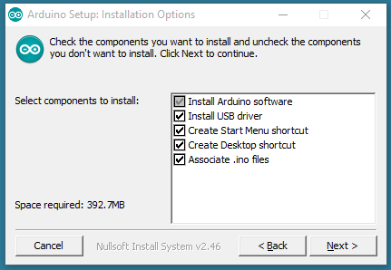

Choose the components to install

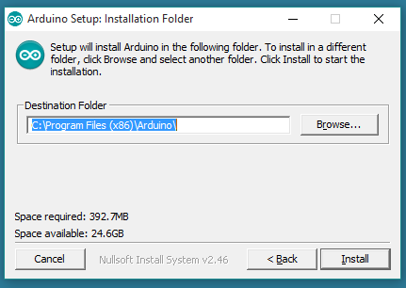

Choose the installation directory (we suggest to keep the default one)

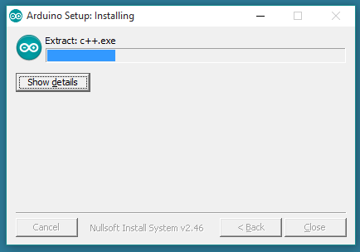

The process will extract and install all the required files to execute properly the Arduino Software (IDE)

## ARDUINO BOOTLOADER ISSUE

The current boot loader burned onto the Arduino UNO is not compatible with ROBOTC. In its current form, you will be able to download the ROBOTC Firmware to the ArduinoUNO, but you will not be able to download any user programs.

The reason for this is because there is a bug in the Arduino UNO firmware that does not allow flash write commands to start at anywhere but the beginning of flash memory (0x000000). See the bottom of this page for more technical details.

Because ROBOTC is not able to burn a new bootloader as of today, you will need to use the Arduino's Open Source language with a modified bootloader file to re-burn your bootloader on your Arduino UNO boards. The enhanced bootloader is backwards compatible with the original one. That means you'll still be able to program it through the Arduino programming environment as before, in addition to ROBOTC for Arduino.

## SOFTWARE NEEDED

ROBOTC is not currently able to burn a bootloader onto an Arduino board, so you'll need to download a copy of the latest version of the Arduino Open-Source programming language.

* Arduino Official Programming Language - [Download Page](http://arduino.cc/en/Main/Software%7CArduino)

In addition, you'll need the ROBOTC modified bootloader. You can download that here:

* ROBOTC Modified UNO Bootloader - [Modified Bootloader](http://cdn.robotc.net/downloads/arduino/stk500boot_v2_mega2560.hex)

## BOOTLOADER DOWNLOAD INSTRUCTIONS

* Download the [Arduino Open Source Software](http://arduino.cc/en/Main/Software) and a copy of the [Modified](http://cdn.robotc.net/downloads/arduino/stk500boot_v2_mega2560.hex) [Bootloader](http://cdn.robotc.net/downloads/arduino/stk500boot_v2_mega2560.hex) File.
* Copy the Modified Bootloader File into the /Arduino- 1.0/hardware/arduino/bootloaders/stk500v2/ and overwrite the existing bootloader.

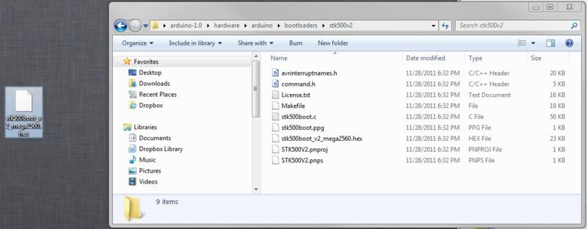

* Power up your Arduino UNO (either via USB or external power)
* Plug in your AVR ISP Programmer to your computer (make sure you have any required drivers installed)
* Connect your AVR ISP Programmer into your Arduino UNO Board via the ISP Header (the 2x3 header pins right above the Arduino Logo)
* Launch the Arduino Open Source Software.
* Change your settings in the Arduino Software to look for an Arduino UNO.
* Change your settings in the Arduino Software to select your ISP Programmer Type (Check your programmer's documentation for the exact model).

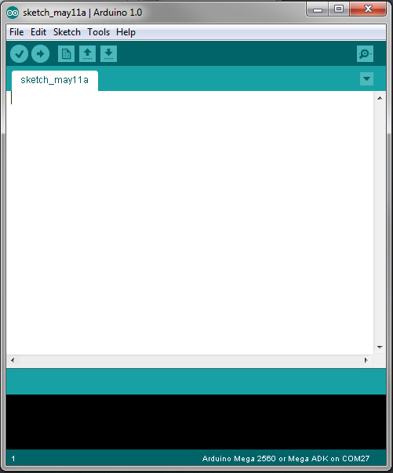

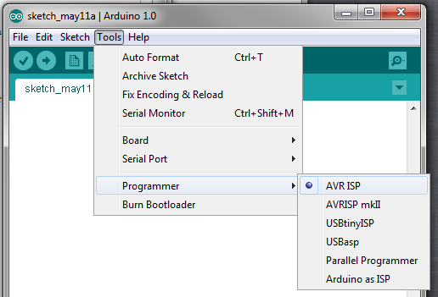

* Select the "Burn Bootloader" option under the "Tools" menu. The modified bootloader will now be sent to your Arduino. This typically takes a minute or so.

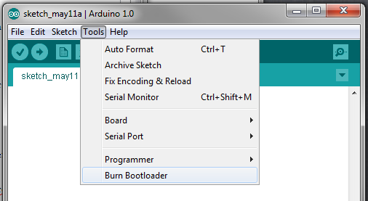

* You should be all set to download ROBOTC firmware and start using your Arduino UNO with ROBOTC.

## SAMPLE CODE

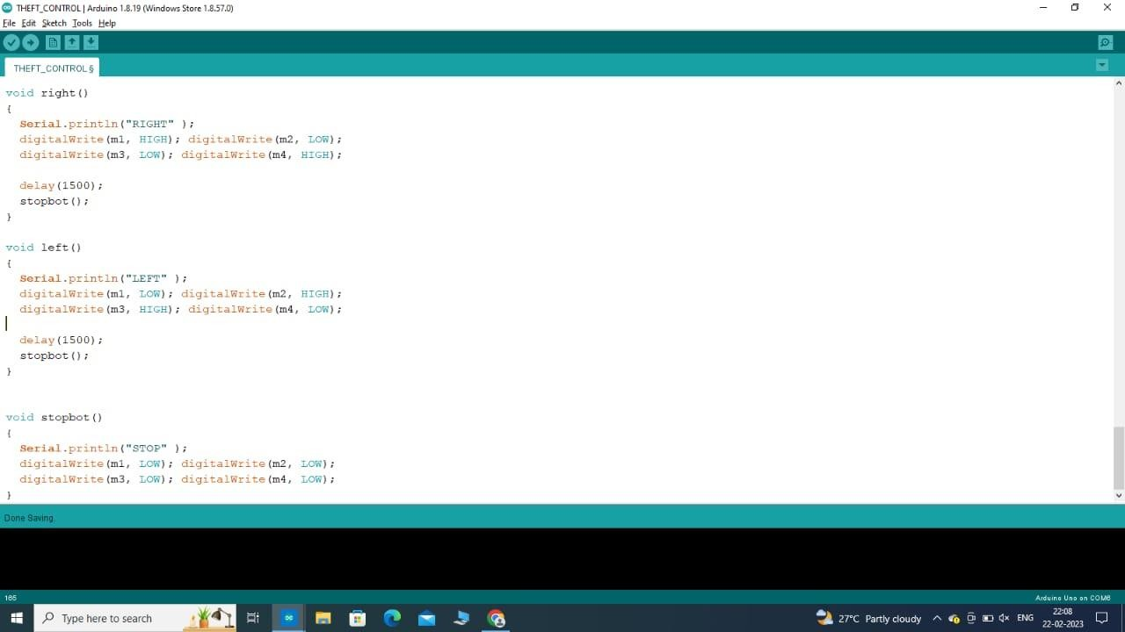

**CHAPTER 7 : WEBSITE DETAILS**

* The **Arduino IDE** is an open-source software, which is used to write and upload code to the Arduino boards. The IDE application is suitable for different operating systems such as Windows, Mac OS X, and Linux.



* **Google Cloud Platform** is developed by Google for creating mobile and web applications. It was originally an independent company founded in 2011. In 2014, Google acquired the platform and it is now their flagship offering for app development
* OpenCV is a library of programming functions mainly for real-time computer vision. Originally developed by Intel, it was later supported by Willow Garage, then Itseez.



* The **HTML** is the standard markup language for documents designed to be displayed in aweb browser. It can be assisted by technologies such as
* CSS and scripting languages such as JavaScript.
* **JavaScript** is high-level, often just-in-time compiled, and multi-paradigm.

•

## HTML:

* + - HTML stands for Hyper Text Markup Language
      * HTML is the standard markup language for creating Web pages
      * HTML describes the structure of a Web page
      * HTML consists of a series of elements
      * HTML elements tell the browser how to display the content
      * HTML elements label pieces of content such as "this is a heading", "this is a paragraph", "this is a link", etc.

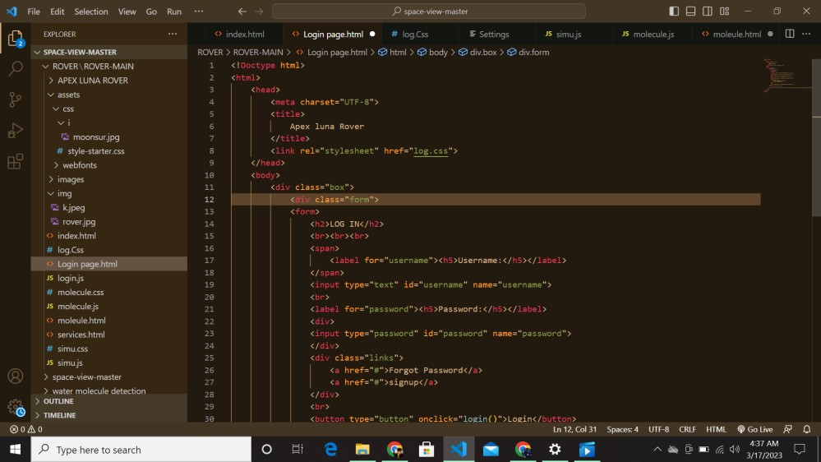

HTML CODE FOR LOGIN SITE

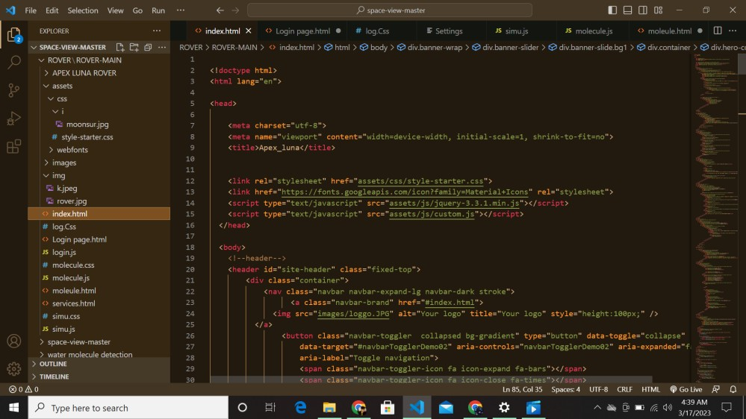

HTML CODE FOR MAIN PAGE

## CSS 3

* + - CSS is the language we use to style an HTML document.
    - CSS describes how HTML elements should be displayed.
    - This tutorial will teach you CSS from basic to advanced.

.

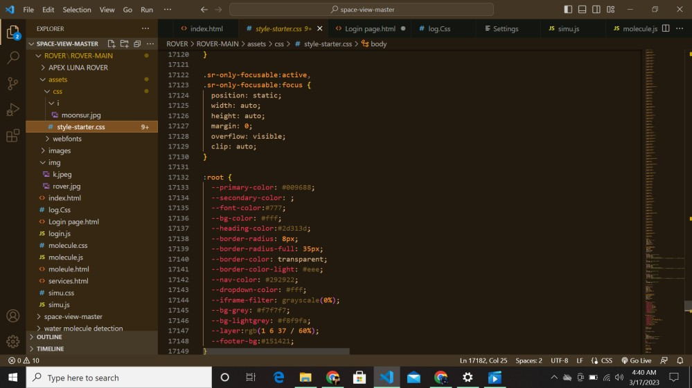

CSS CODE FOR MAIN PAGE

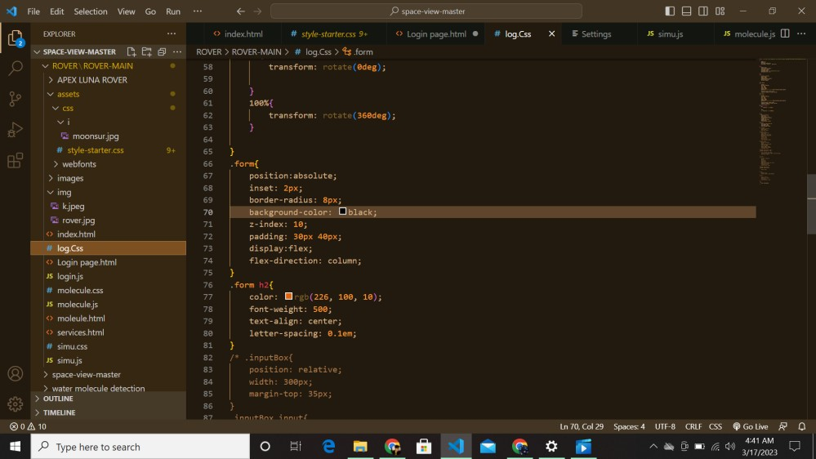

CSS CODE FOR LOGIN PAGE

## JAVASCRIPT:

* + - JavaScript is the world's most popular programming language.
      * JavaScript is the programming language of the Web.
      * JavaScript is easy to learn.
      * This tutorial will teach you JavaScript from basic to advanced.

## OPEN CV:

OpenCV is a library of programming functions mainly for real-time computer vision. Originally developed by Intel, it was later supported by Willow Garage, then Itseez.

## 7.4.1 WATER MOLEULE DETECTION

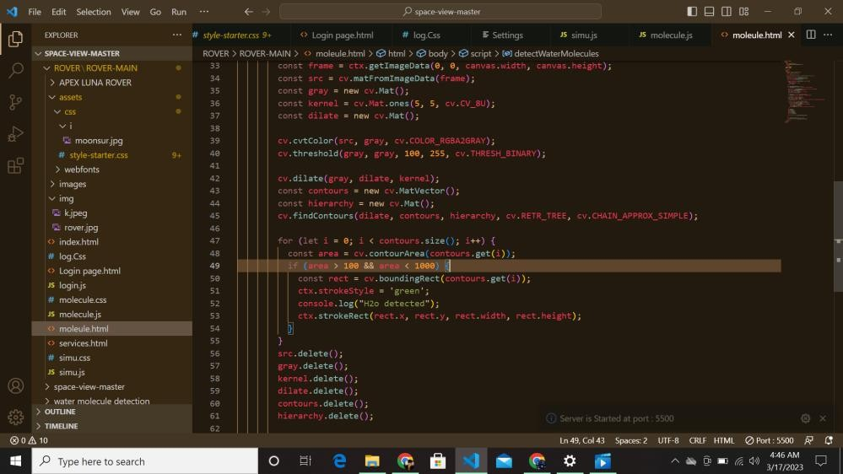

CODE FOR WATER MOLECULE DETECTION

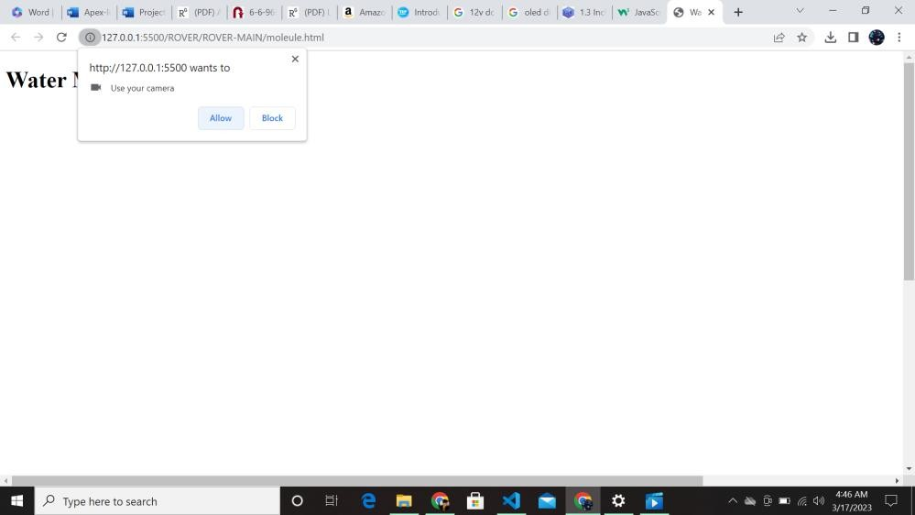

OUTPUT

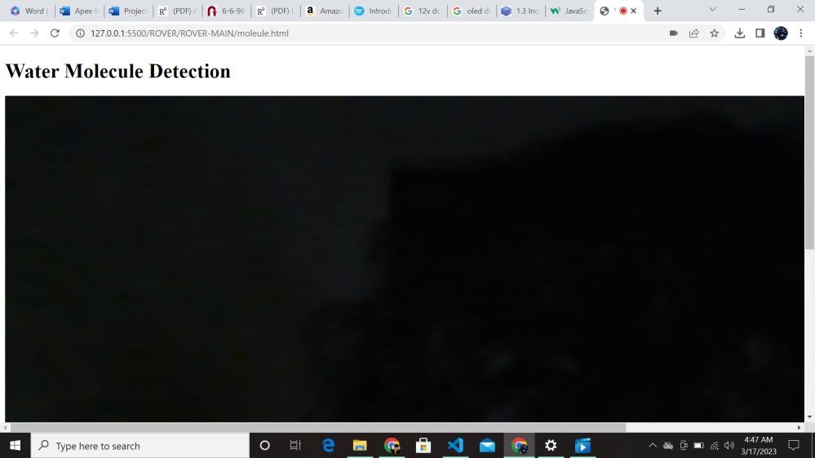

## WEBSITE PICS:

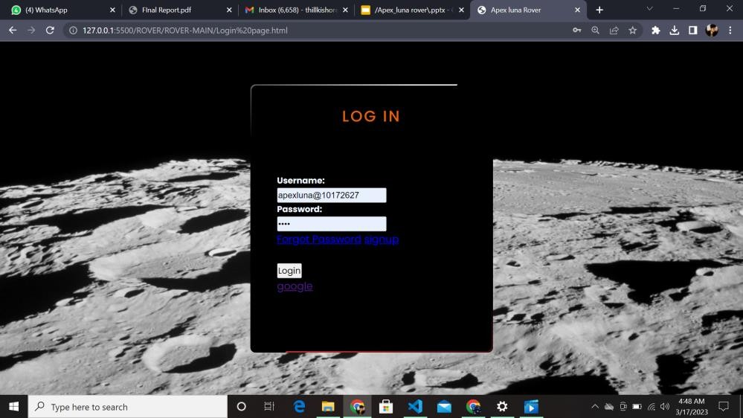

LOGIN WEBPAGE

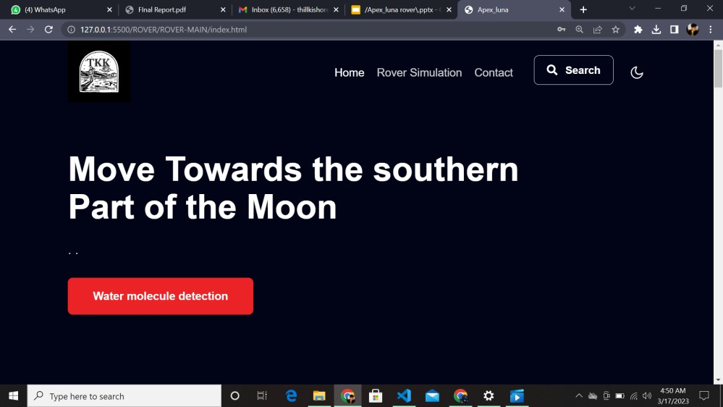

Main page

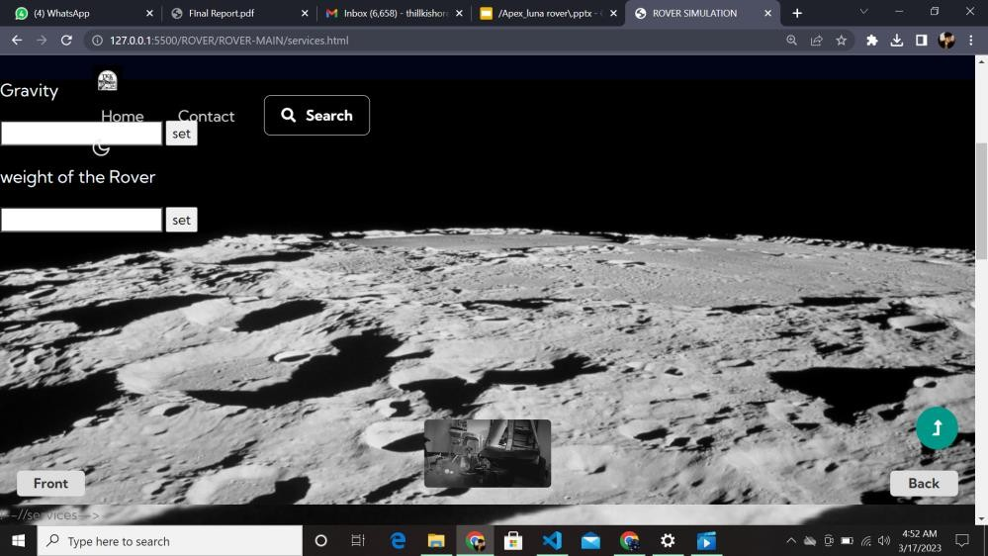

ROVER SIMULATOR PAGE

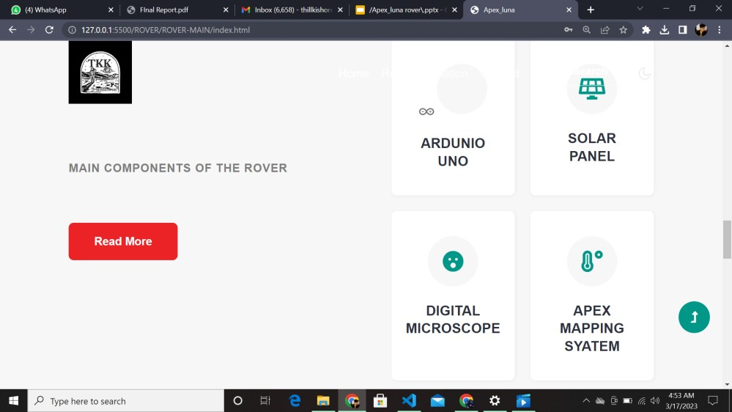

COMPONENTS OF THE ROVER

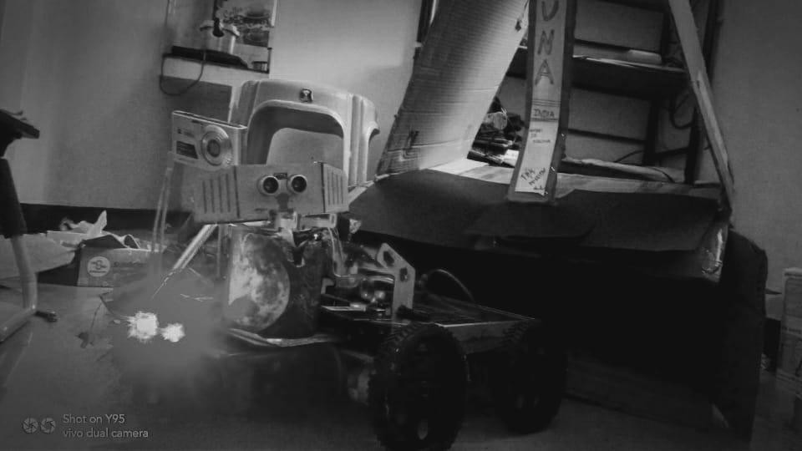

APEX-LUNA ROVER IMAGE

# CONCLUSION

Hence in the south pole region features many craters and basins such as the South Pole–Aitken basin, which appears to be one of the most fundamental features of the Moon, and mountains. So based on that theory till now the NASA and ISRO hadn’t land and analysis on the souther part of moon .Our main motive is to land

the rover on safe side of the tranquility base which is the 00°41′15″N, 23°26′00″E landing site according to author collins. Upto this date no one has successfully landed the southern Nobile rim 2 surface according to theory of collins. In Exisiting Rover which can capture the photo and then travel some short distance and collect the samples but our rover can map the moon and analysis water structure molecules and travel for long distance with help of three methods of battery system, So thus our idea can be useful form the 3 main probllems in the rover in future we are going to work for the mission under venus plant with automated rover.

# REFERENCES

* **"Impact Basin Database". Archived from the original on 2014-08-07. Retrieved 2017-01-23.**

# ^ Geologic Map of the Near Side of the Moon, USGS I-703, Don E. Wilhelms and John F. McCauley, 1971 (L&PI web version)

* **^ "Observatorio ARVAL - Moon Map". Observatorio ARVAL. Retrieved 2009-07-04.**

|  |  |  |
| --- | --- | --- |
| * **^ Ewen A. Whitaker, Mapping and Naming** | **the** | **Moon** |
| **(Cambridge University Press, 1999), p.61.** |  |  |
| * **^ Ewen A. Whitaker, Mapping and Naming** | **the** | **Moon** |
| **(Cambridge University Press, 1999), p.15** |  |  |
| * **^ Ewen A. Whitaker, Mapping and Naming** | **the** | **Moon** |
| **(Cambridge University Press, 1999), p.41** |  |  |